**Title:** The Implications of infrastructure development in Abuja, Nigeria

**Author:** Arham Siddiqi

**Introduction:**

One of the biggest obstacles stopping a third-world country from developing is poverty. Nigeria is a perfect example of this. In 2010, 92% of its population were living on less than $2.00 per day and this extreme poverty has led to political corruption, high crime rates, income inequality, poor education, and more (Ucha 2010). A contributing factor to this poverty is the lack of proper infrastructure like paved roads, public transportation, and power supplies to facilitate the needs of the country’s citizens. Good infrastructure greatly assists a country’s socioeconomic factors, environment, poverty, population growth, political stability, and more (Rao 2016). So, an integral part of alleviating the many issues plaguing the Nigerian people would be to develop the country’s infrastructure. This can also exponentially improve its economy since foreign companies and individuals will be more likely to invest in countries that have good stability and development (“How Developing Countries” 2018). Prolonged positive investment ventures can lead to beneficial trade relations being formed with Nigeria and other countries, further improving the economy of the nation and stimulating the growth of multiple industries (Blomström & Kokko 1996).

The aim of this project is to track the infrastructure development of Abuja, Nigeria from 2000 to 2021 through analyzing the increase in built-up areas in the city. This data would not only indicate the progress that Abuja has made in terms of its infrastructure, but also show the increase in potential the city has in improving the quality of life of its residents due to the association between good infrastructure and a city’s overall health.

**Methodology:**

This project is a time-series and change analysis which compares the built-up areas of several satellite images of Abuja taken over 21 years. This analysis portrays the infrastructure development of the city through tracking differences in the Normalized Difference Built-up Index (NDBI) which is a numerical value that highlights built-up areas. I used Landsat 7 and Landsat 8 data. Landsat 7 provided images from the year 2000 before Landsat 8 was even launched. Landsat 8 was used to gain high quality images from the year 2021 that did not have data gaps in the form of unnatural lines going through the images as is the case with Landsat 7 after 2003. The central business district of Abuja as well as the surrounding areas were outlined for analysis in Google Earth Engine. The time period of study was between January and May of every year from 2000 to 2021. This month range is a relatively dry season for Abuja which limits NDBI values being interfered with by the reflectance caused by rain.

Once the area and times of interest were isolated, I created multiple image collections to begin analysis. I created simple composites from the image collections and mapped them. I then generated statistics that measured the difference and percentage increase of mean NDBI values from 2000 and 2021. This was done by adding an NDBI band to the image composites and using a reduce region function to generate the NDBI means and then calculating the percentage increase with a formula in mean NDBI from 2000 and 2021. I then created a function to add NDBI bands to the original image collections I made in order to isolate the 80th percentile of NDBI values of Abuja and map them. Finally, I created a time-series scatter plot with a best fit line that shows the mean NDBI values of Abuja from 2000 – 2021.

**Results:**

**Figure 1**

|  |  |
| --- | --- |
| Part A: Abuja, Nigeria NDBI display from bands 5 and 4 in a Landsat 7 imagery composite of the year 2000 | Part B: Abuja, Nigeria NDBI display from bands 6 and 5 in a Landsat 8 imagery composite of the year 2021 |

**Figure 2**

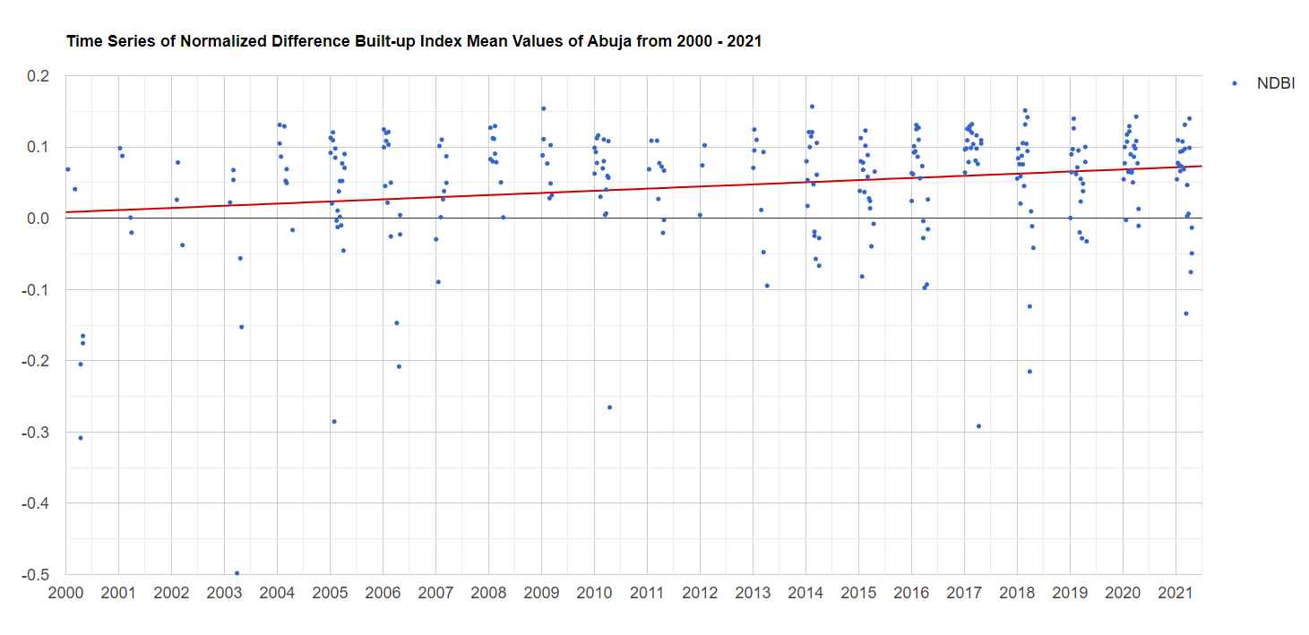

Time series scatter plot with best fit line of Abuja, Nigeria mean NDBI values from January – May of every year between 2000 and 2021

**Figure 3**

|  |  |
| --- | --- |
| Part A: Abuja, Nigeria 80th percentile NDBI display from bands 5 and 4 in a Landsat 7 imagery composite of the year 2000 | Part B: Abuja, Nigeria 80th percentile NDBI display from bands 6 and 5 in a Landsat 8 imagery composite of the year 2021 |

**Figure 4**

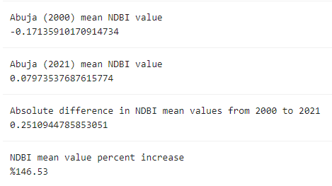

NDBI statistics generated from reducer mean functions using bands 5 and 4 in a Landsat 7 imagery composite of the year 2000 as well as bands 6 and 5 in a Landsat 8 imagery composite of the year 2021.

**Results Interpretation:**

Figure 1 shows a sizeable increase in NDBI mean values from Abuja in 2021 compared to Abuja in 2000. This is depicted by the image on the right (figure 1 part B) being much brighter than the image on the left (figure 1 part A) relatively speaking. This means that there was good progress in infrastructure development of the city from 2000 to 2021. The 80th percentile comparison in figure 3 explains where exactly the infrastructure development efforts were focused. Since both images in figure 3 have relatively similar brightness which means that the top 20% of NDBI values in 2000 were mostly similar in magnitude of NDBI values in 2021. This means that well-established areas in the year 2000 were not expanded upon nearly as much as underdeveloped areas over the next 2 decades. Indicating that most of the resources spent on infrastructure development in the city were focused on areas that severely lacked good infrastructure in the year 2000. Figure 2 portrays an oscillating pattern of NDBI mean values which is not intended. This trend is the result of surface reflectance interfering with the NDBI values. Landsat 7 TOA Reflectance was used to partially mitigate this problem by accounting for the interference of clouds, gases, and aerosols. Limiting the time period of study to Abuja’s dry season lessened the interference of surface reflectance, but it was still enough of a problem that it caused very unexpected variation of NDBI mean values. Regardless, the best fit line still shows a modest positive relationship between time and mean NDBI values which is another way of visualizing the improvement in infrastructure development of the city from 2000 to 2021. Figure 4 is a set of stats that indicate a significant increase in NDBI mean values. A %146.53 increase in mean NDBI from 2000 to 2021 shows that Abuja more than doubled the overall quality of the city’s infrastructure. It is important to note that their starting point was quite low at a mean NDBI of about –0.17 so more than doubling the quality of infrastructure when the standard is already very low to begin with may sound more substantial than it actually is.

**Significance/Discussion:**

The findings indicate that a sizeable improvement has occurred in Abuja’s infrastructure from the year 2000 to 2021 based on the stark difference in mean NDBI values of figure 4 and the much brighter 2021 image of figure 1 part B compared to the dark image of figure 1 part A. Most of that effort was dedicated to the severely underdeveloped parts of the city which is evident from the similar 80th percentile results of figure 3. There could be two reasons for this, either Abuja is very focused on bringing the extremely underdeveloped parts of the city up to living standards in terms of their infrastructure, or the resources and time required to build up extremely poor areas are far less than to expand on already developed sectors which demand greater resources and time investment which explains the similar 80th percentile comparison, but stark difference of the normal NDBI comparison in figure 1. Either or both of these ideas could be true, but regardless, Abuja has made a more than minor improvement in their infrastructure overall.

Without proper infrastructure, it can be very difficult to tap into the full potential of a city or country’s residents which is one of the major contributing factors to Nigeria’s poverty. The infrastructure development of Abuja can set a positive example for the rest of the country since it is the capital. The resources being focused on severely underdeveloped areas could greatly assist poor individuals in getting a secure job in the central business district of the city. This would not only improve the economy of the city, but help many families get out of poverty. The reduction in poverty could have a positive cascading effect on the city by reducing crime rates, political corruption, income inequality, and more as mentioned in the introduction. Foreign businesses and individuals would see Abuja as an appealing city to invest in due to the increase in infrastructure development indicating a new growing market which could exponentially improve the opportunities that the residents of Abuja have. All these doors that could potentially be opened result from the improvement of infrastructure that facilitates the needs of the people in Abuja and the rate at which they are improving based on the data from this research report indicates that the city is on the right track to making all this potential a reality in the future.

**Code Link:** <https://code.earthengine.google.com/e5af2d09d93597d645f052b553715a2a>

**References:**

Blomström, M., & Kokko, A. 1996. “The Impact of Foreign Investment on Host Countries: A Review of the Empirical Evidence.” *ResearchGate.* <https://www.researchgate.net/publication/23721977_How_Foreign_Investment_Affects_Host_Countries>

2018 “How Developing Countries Can Get the Most out of Direct Investment.” *World Bank*, World Bank Group 19. <https://www.worldbank.org/en/topic/competitiveness/publication/global-investment-competitiveness-report>.

Rao, P. 2016 “Infrastructure Development and Economic Growth: Prospects and Perspective.” *Academia.edu*, Blue Ocean Research Journals. <https://www.academia.edu/24400230/Infrastructure_Development_and_Economic_growth_Prospects_and_Perspective>.

Ucha, C. 2010 “Poverty in Nigeria: Some Dimensions and Contributing Factors.” *Global Majority E-Journal*, vol. 1, no. 1, pp. 46–56. <https://www.american.edu/cas/economics/ejournal/upload/ucha_accessible.pdf>